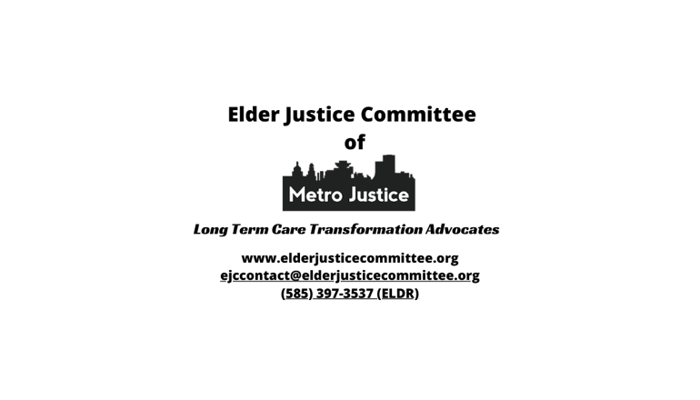
ADULT ABUSE

An intentional or negligent act that causes harm to a vulnerable person. Including:
- Neglect
- Isolation from others
- Withholding or not providing appropriate quality food, medicine, PT, OT, hydration, medical care
- Withholding walkers, wheelchairs, glasses, hearing aids
- Withholding TV, radio, computer, phone, and mail
- Blocking or limiting visitors
- Insufficient, undignified, unsafe, unhealthy personal care
- Emotional abuse and intimidation
- Physical abuse
- Sexual abuse
- Remove or Block Cameras
- Theft

IF YOU OR SOMEONE YOU KNOW IS EXPERIENCING NEGLECT OR ABUSE
LET SOMEONE KNOW!

IN A REHAB or LONG TERM CARE FACILITY:
New York State Ombudsman Program 585-287-6414

New York State Department of Health (DOH) Complaint Hotline:
888-201-4563 OR www.health.ny.gov/facilities/nursing/complaints
NYS DOH Regional Office: Buffalo 716-847-4302; Rochester 585-423-8100

AT HOME or IN THE COMMUNTY:
Monroe County - Adult Protective Services: 585-753-6532
After-hours emergencies: 585-461-5698

Other Counties - NY Connects: 1 (800) 342-9871

*AA2025E-06J-19*

