NURSING HOME RESIDENTS’ RIGHTS

Policies covering the rights of residents are established by State and Federal regulations. The nursing home must implement these policies and explain them to residents. The nursing home must also post a Residents' Bill of Rights in the building for easy viewing and reading.
Be sure to notice it and ask any questions you have about its provisions.

Any person requiring nursing home care should be able to enter any nursing home and receive appropriate care, be treated with courtesy and enjoy continued civil and legal rights. Nursing home residents have the right to:

- dignity, respect, and a comfortable living environment
- quality of care and treatment without discrimination
- freedom of choice to make your own, independent decisions
- be informed in writing about services and fees before you enter the nursing home
- the safeguard of your property and money
- appeal a transfer or discharge with the New York State Department of Health
- privacy in communications
- choose your own schedule, activities and preferences that are important to you
- receive visitors of your choosing at the time of your choosing
- an easy-to-use and responsive complaint procedure
- be free from abuse including verbal, sexual, mental, and physical
- be free from restraints
- exercise all your rights without fear of reprisals
- participate in planning and view the full resident care plan

Ask the nursing home administrator for the booklet entitled "Your Rights as a Nursing Home Resident in New York State and Nursing Home Responsibilities."

NURSING HOME COMPLAINTS should be made to New York State Department of Health (NYS DOH) Complaint Hotline 888-201-4563 (24 hours a day, seven days a week) OR Fax 518-408-1157

OR File Online at: www.health.ny.gov/facilities/nursing/complaints Surveyors/inspectors investigate the complaint to make a determination if State or Federal regulations have been violated.

And to the Long Term Care Ombudsman Program (LTCOP) a federal advocacy program to protect people living in long-term care facilities. LTCOP advocates for residents by investigating and to help resolve complaints made by or on behalf of residents with the resident’s permission

Contact information: www.ltcombudsman.ny.gov

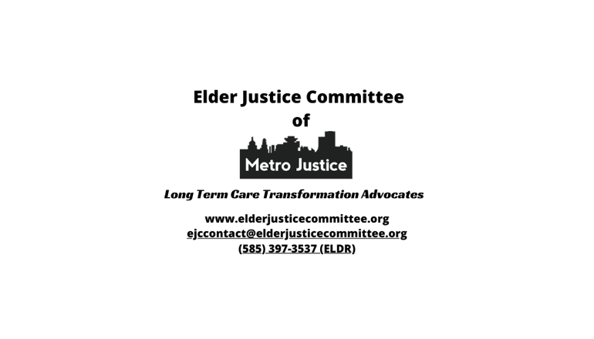

*RR2025E-06J-19*

